**Exercise 1: Logging Error Messages and Warning Levels**

**Task: Write a Java application that demonstrates logging error messages and warning levels using SLF4J.**

**Step-by-Step Solution:**

**1. Add SLF4J and Logback dependencies to your 'pom.xml' file:**

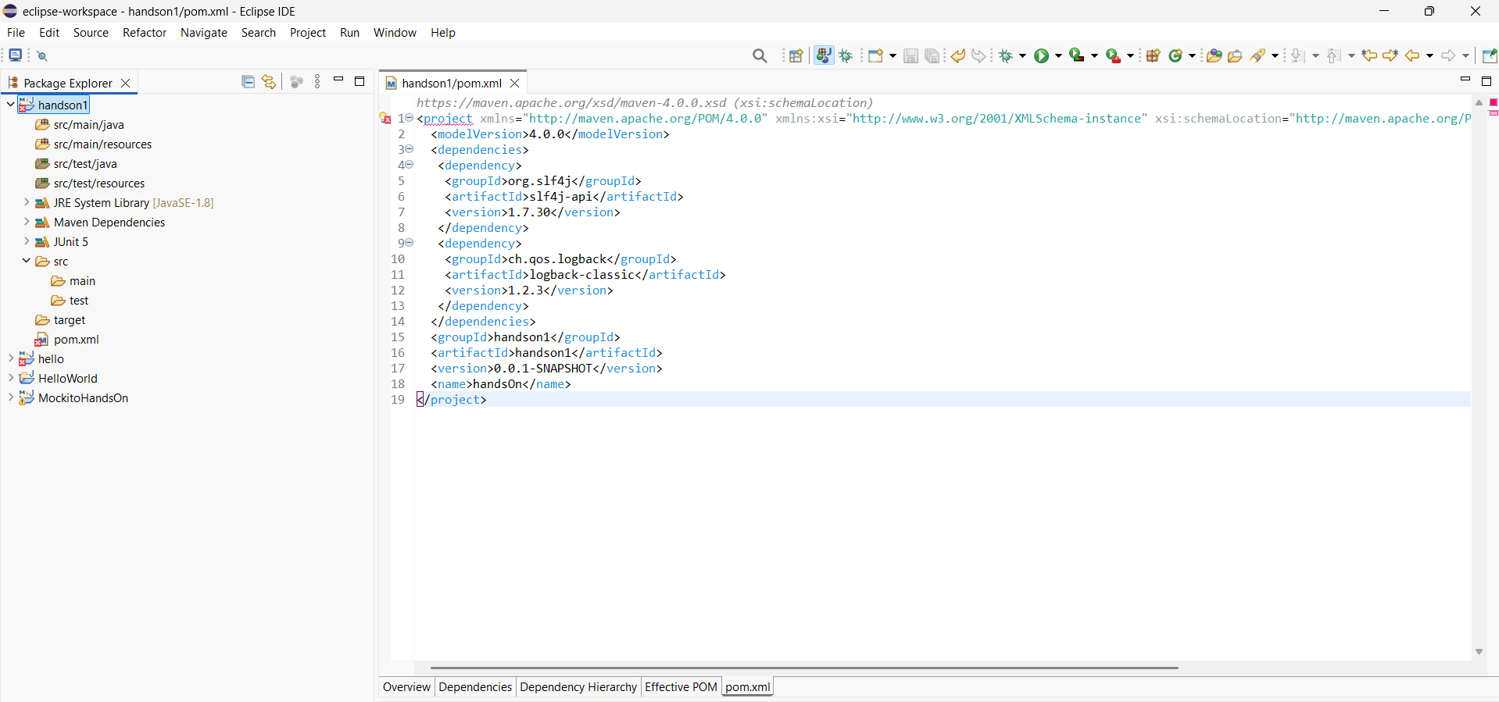

**2. Create a Java class that uses SLF4J for logging:**

**SOLUTION:**

package logging;

import org.slf4j.Logger;

import org.slf4j.LoggerFactory;

public class LoggingExample {

private static final Logger *logger* = LoggerFactory.*getLogger*(LoggingExample.class);

public static void main(String[] args) {

*logger*.error("This is an error message");

*logger*.warn("This is a warning message");

*logger*.info("This is an info message");

}

}

